

**PSYCHOLOGY SURVEY REPORT**

**Topic: Understanding Nightmares and Its Impact on Anxiety**

**Submitted To:** Miss Sehar Waheed **Degree:** BSSE **Section:** 3B

**Submitted By:** Group 4

Abeer Tahir 23L-3090

Ali Ahmad 23L-3067

Ayka Imran 23L-3051

Eisha Naz 23L-3045

Fatima Tuz Zahra 23L-3099

Minahil Kamil 23L-3098

Sarmad Irfan 23L-3002

Syed Hadi Ali Akbar Zaidi 23L-3023

**Acknowledgment**

We would like to express our heartfelt gratitude to everyone who contributed to the success of this survey. This project was a collaborative effort, and we are deeply appreciative of the hard work and dedication shown by all the group members. Each member played a vital role in designing the survey, collecting responses, and analyzing the data.

Additionally, we extend our thanks to all the participants who took the time to share their valuable insights and experiences. Without their willingness to engage, this survey would not have been possible.

This project was an incredible learning experience, and we are proud of the teamwork and commitment that led to its completion.

**Abstract**

This study investigates the relationship between nightmares and anxiety levels in individuals. A survey was conducted with 71 participants to assess the frequency, intensity, and emotional impact of nightmares, as well as their perceived connection to anxiety. The findings suggest a correlation between frequent nightmares and higher levels of anxiety, particularly in terms of emotional distress and physical symptoms. However, the relationship is complex, with individual experiences varying significantly. While some participants reported significant disruptions to their sleep and daily lives, others were able to cope with nightmares without major adverse effects. The study highlights the need for further research to explore the underlying mechanisms and potential interventions to alleviate nightmare-related distress and anxiety.

**Work Done by Group Members:**

The team members effectively collaborated to bring the research project to fruition. Ayka Imran took the lead in data collection, meticulously designing and administering a 25-item Google Form survey. She also played a pivotal role in consolidating the work of all team members and formatting the final survey report . Abeer Tahir and Minahil Kamil focused on the methodological aspects of the study, identifying appropriate data sources, instruments, and collection techniques. Syed Hadi Ali Akbar Zaidi, Sarmad Irfan, and Ali Ahmad delved into the existing literature, conducting a comprehensive review to establish a strong theoretical foundation for the research. Fatima Tuz Zahra and Eisha Naz were responsible for data analysis and interpretation, employing appropriate statistical techniques to extract meaningful insights from the collected data. Their combined efforts were instrumental in ensuring the successful completion of the research project.

**Table of Contents**

1. Acknowledgment --------------------------------------------------------- Page 2
2. Abstract -------------------------------------------------------------------- Page 3
3. Work of Group Members ------------------------------------------------ Page 4
4. Table of Contents --------------------------------------------------------- Page 5
5. Survey Description ------------------------------------------------------- Page 6-8
6. Chapter 1 ------------------------------------------------------------------ Page 9
7. Chapter 2 ------------------------------------------------------------------ Page 9-20
8. Chapter 3 ------------------------------------------------------------------ Page 20-23
9. Chapter 4 ------------------------------------------------------------------ Page 23-28
10. Chapter 5 ------------------------------- Page 28-30
11. References ------------------------------ Page 31-32

**Survey Method: A Detailed Description**   
 A survey is a research technique that uses a set of questions to gather information from a sample of people. It is an organized method for learning about people's attitudes, convictions, actions, or expertise.   
**When to Use a Survey**   
 Surveys are highly effective tools for gathering information in various contexts. They are particularly useful when dealing with large sample sizes, as they enable the collection of data from a wide range of individuals efficiently. Surveys are ideal for obtaining quantitative information that can be subjected to statistical analysis, providing valuable insights into trends and patterns. They facilitate the collection of standardized data, allowing for comparisons over time or between different groups. Additionally, surveys are an excellent method for examining attitudes and opinions, offering a deeper understanding of how people feel about specific topics or issues.

**Procedures for the Survey Method** Conducting an effective survey involves several key steps to ensure the validity and reliability of the findings. First, it is essential to establish the goals of the study by clearly defining the specific objectives the survey aims to achieve. Next, a well-organized questionnaire should be created, with questions designed to be clear, concise, and relevant to the study's purpose. Selecting an appropriate sample that represents the target population is crucial for obtaining meaningful results. The survey method must then be chosen, whether it is conducted in person, online, or through mail, depending on the resources available and the target audience. Once the questionnaire is distributed, data is gathered and compiled for analysis. Proper statistical methods are then applied to process and examine the collected data. Finally, the results are interpreted, enabling meaningful inferences to be drawn and findings to be reported effectively.

**Selection of Samples**  
 A sample is a subset of the population selected to represent the entire group, and choosing a representative sample is vital to ensure the survey results are accurate and widely applicable. Various sampling methods can be employed depending on the research objectives and population structure. Random sampling is a common method where every individual in the population has an equal chance of being chosen, minimizing bias and enhancing the reliability of results. Stratified sampling is used when the population is divided into distinct subgroups, or strata, based on specific characteristics, with a random sample drawn from each subgroup to ensure proportional representation. Cluster sampling involves dividing the population into clusters, such as geographical regions or organizational units, and then randomly selecting clusters to include in the sample. Each of these methods serves to enhance the precision and applicability of survey findings.

**Survey and Interview**  
**•** *Survey:* A list of written enquiries intended to elicit data from participants. There are several ways to administer questionnaires, including online, mobile, and paper-based.  
***•*** *Interview:* A phone call or in-person discussion with respondents to obtain data. There are three types of interviews: semi-structured, unstructured, and structured.  
**Online vs. In-person Surveys**  
*• In-person surveys:* Benefits include increased response rates, more profound understanding, and question clarification. Drawbacks include expensive, time-consuming, and subject to interviewer prejudice.

*• Online questionnaires:* Benefits include economical, rapid data gathering, extensive reach, and multimedia compatibility. Drawbacks include self-selection bias, lower response rates, and the possibility of technological issues.  
**Question Types**  
• *Closed-ended questions*: Give precise options for responses (e.g., multiple-choice, yes/no, Likert scale).  
• *Open-ended questions*: Let participants give thorough responses in their own terms.  
**Scales of Rating**  
Rating scales, such as the five-point Likert scale, are used to measure attitudes, beliefs, or behaviors along a continuum, ranging from "strongly agree" to "strongly disagree." The Semantic Differential Scale, on the other hand, assesses attitudes through bipolar opposites like strong/weak or good/bad. Surveys offer several benefits, including efficiency in gathering data, standardization for consistency, anonymity that may encourage honesty, and versatility across various subjects. However, they also have drawbacks, such as self-report bias, non-response bias from low participation, limited depth in capturing complex feelings, and the risk of question bias influencing responses.

**Chapter 1: Introduction**

Dreaming is a universal phenomenon that most people experience in their everyday lives, often reflecting the workings of the subconscious mind, past memories, and recent events. Among the many forms of dreams, nightmares stand out as vivid and often distressing experiences that can leave a lasting emotional impact. These unsettling dreams evoke intense feelings of fear, discomfort, and anxiety, potentially affecting an individual's mental health. Some psychologists classify nightmares as a form of parasomnia, a category of sleep disturbances, and frequent occurrences may indicate underlying sleep disorders.

To explore the connection between nightmares and anxiety, a survey was conducted using Google Forms, with 71 participants aged 18 and above sharing their experiences. The responses provided insights into the frequency and intensity of nightmares and their potential link to anxiety levels. This raises an important question: do individuals who experience frequent nightmares report higher levels of anxiety compared to those who rarely have such experiences? Understanding this relationship offers valuable insights into the psychological effects of nightmares and their broader implications for mental well-being.

**Chapter 2: Literature Review**

1. **Insights from Books:**

* **“The Interpretation of Dreams" by Sigmund Freud (1900):**

Freud's groundbreaking work is foundational to understanding the psychoanalytic perspective on nightmares. He argues that nightmares are expressions of repressed fears and desires, disguised within symbolic imagery. For example, a recurring nightmare of falling might represent fear of failure or loss of control. Freud also connects nightmares to unresolved conflicts from early childhood, positing that they offer a glimpse into the unconscious.

* **“Man and His Symbols" by Carl Jung (1964):**

This book, a collaboration between Carl Jung and his disciples, delves into the symbolic meaning of dreams. Jung views nightmares as signals from the subconscious, urging individuals to address aspects of their psyche they have ignored or suppressed. A nightmare featuring a dark figure, for instance, might symbolize the "shadow self," representing the hidden parts of one's identity.

* **“Why We Sleep" by Matthew Walker (2017):**

Matthew Walker, a neuroscientist, explores the biological processes underpinning sleep and dreams. He explains how nightmares arise during the REM stage of sleep, emphasizing their role in emotional regulation. Walker also discusses how disrupted sleep cycles, often caused by stress or anxiety, can amplify the frequency and intensity of nightmares.

* **“Dreams and Nightmares: The Origin and Meaning of Dreams" by Ernest Hartmann (1998):**

Hartmann’s book links nightmares to emotional responses, suggesting they help the brain process intense emotions and integrate them into memory. Trauma-related nightmares, for instance, may act as the brain's way of grappling with distressing experiences, offering a pathway to healing if understood.

* **"Nightmares: The Science and Solution of Those Frightening Visions During Sleep" by Rosalind Cartwright (2010):**

Cartwright focuses on the therapeutic potential of nightmares. She argues that they are not merely disruptive but can serve as tools for resolving unresolved emotional conflicts. Her research includes case studies where patients experiencing recurrent nightmares found relief through techniques like Imagery Rehearsal Therapy (IRT).

1. **Insights from Articles:**

* **"Nightmares as Predictors of Anxiety and Depression: A Longitudinal Study" (Sleep Medicine Reviews, 2015):**

Freud's groundbreaking work is foundational to This article examines how frequent nightmares can predict the onset of anxiety and depression. Over a three-year period, researchers tracked 1,000 participants, finding a significant correlation between nightmare frequency and heightened anxiety symptoms.

* **"The Role of Cortisol in Nightmares and Sleep Disturbances" (Journal of Clinical Psychology, 2018):**

This study links increased cortisol levels (a stress hormone) with the prevalence of nightmares. Participants with high cortisol levels reported vivid and emotionally intense nightmares, suggesting a physiological basis for the phenomenon.

* **"Cultural Themes in Nightmares: A Cross-Cultural Analysis" (International Journal of Dream Research, 2020):**

The researchers analyzed nightmare themes across cultures, revealing that sociocultural factors heavily influence their content. For example, individuals from conflict zones reported nightmares centered on war and displacement, while Western participants often dreamed of personal failure.

* **"Nightmares and Their Association with PTSD" (Journal of Traumatic Stress, 2019):**

This article highlights how trauma-related nightmares are a hallmark of PTSD. The authors discuss the use of therapies like Eye Movement Desensitization and Reprocessing (EMDR) to address these nightmares.

* **"Sleep Apnea and Nightmare Frequency: A Surprising Link" (Chest Journal, 2021):**

This medical study explores how sleep apnea, a disorder causing interrupted breathing during sleep, increases the likelihood of nightmares. Treating sleep apnea with CPAP machines significantly reduced nightmare frequency.

* **"Imagery Rehearsal Therapy for Nightmare Reduction" (Behavioral Sleep Medicine, 2017):**

A clinical trial on Imagery Rehearsal Therapy (IRT) demonstrated its effectiveness in reducing nightmare frequency. Participants visualized positive endings for their nightmares during waking hours, which lessened the emotional intensity of their dreams.

* **"The Genetic Basis of Nightmares" (Nature Communications, 2021):**

This groundbreaking study identifies genetic markers linked to nightmare susceptibility. Twin studies revealed that individuals with certain genetic traits were more prone to recurrent nightmares, suggesting a hereditary component.

* **"Nightmares in Adolescents: The Impact of Academic Stress" (Journal of Adolescent Health, 2020):**

This article examines how academic pressures contribute to nightmares in teenagers. High-achieving students reported dreams of failing exams, reflecting their anxieties.

* **"Gender Differences in Nightmare Frequency and Content" (Dreaming, 2016):**

This study found that women are more likely to experience nightmares than men, possibly due to differences in emotional processing. Women’s nightmares often included themes of loss or interpersonal conflict.

* **"The Evolutionary Purpose of Nightmares" (Current Biology, 2020):**

Cartwright This article theorizes that nightmares may have an evolutionary function, preparing individuals for real-life threats by simulating danger scenarios. For instance, a nightmare about being chased might reflect ancestral survival instincts.

1. **Pakistani and International Studies:**

* **Pakistani Study: "Sociocultural Influences on Nightmare Themes in Displaced Populations" (Journal of South Asian Studies, 2021):**

This study examines how displacement and sociopolitical trauma shape nightmares. Refugees reported recurring dreams of losing family members or being unable to return home, reflecting their lived realities.

* **Pakistani Study: "Academic Stress and Nightmares Among University Students" (Pakistan Journal of Psychology, 2020):**

This research highlights the prevalence of anxiety-induced nightmares among students facing high academic pressure. Coping strategies, such as mindfulness, reduced nightmare frequency.

* **Dutch Study: "Effectiveness of Imagery Rehearsal Therapy for Nightmares in PTSD Patients" (The Lancet Psychiatry, 2019):**

The study found that IRT reduced nightmares by 70% in PTSD patients over six months. It highlighted the therapy’s potential in treating both nightmares and associated anxiety symptoms.

* **U.S. Study: "The Heritability of Nightmare Disorder" (American Journal of Psychiatry, 2020):**

This research identified specific genetic markers that increase susceptibility to nightmares, paving the way for personalized treatments.

1. **Causes and Common Interpretations:**

Nightmares often arise from an intricate web of psychological, physiological, and environmental factors. Their underlying causes are varied:

* 1. **Psychological Causes**:
* **Stress and Anxiety**: Heightened stress levels, whether due to personal conflicts, work pressure, or societal issues, often manifest in vivid nightmares. A student under academic pressure may dream of failing exams or being unprepared for class.
* **Trauma**: Traumatic experiences, such as abuse or witnessing violence, are closely tied to nightmares. In PTSD sufferers, nightmares often replay traumatic events with startling clarity.
* **Mental Health Disorders**: Depression, bipolar disorder, and generalized anxiety disorder are all linked to increased nightmare frequency.
  1. **Physiological Causes**:
* **Medication**: Certain medications, such as antidepressants, beta-blockers, or sleep aids, can alter sleep patterns and trigger vivid dreams.
* **Substance Abuse**: Withdrawal from substances like alcohol, caffeine, or recreational drugs often leads to disturbed sleep and intense nightmares.
* **Neurological Conditions**: Disorders like epilepsy or Parkinson’s disease may contribute to frequent nightmares due to altered brain activity.
  1. **Environmental Factors**:
* **Sleep Environment**: Poor sleep hygiene, such as sleeping in noisy or uncomfortable conditions, increases nightmare susceptibility.
* **Diet**: Eating heavy meals close to bedtime can disrupt sleep cycles and provoke nightmares.
  1. **Psychoanalytic and Cognitive Interpretations**:
* **Psychoanalytic Theory**: Freud suggested that nightmares symbolize suppressed emotions or desires. For instance, a dream of drowning might symbolize feeling overwhelmed in real life.
* **Cognitive-Behavioral Theory**: Nightmares are seen as the brain's attempt to rehearse threats or process difficult experiences. This aligns with the evolutionary perspective that dreams prepare individuals for real-life challenges.

1. **Time of Occurrence:**

Nightmares predominantly occur during the **REM (Rapid Eye Movement) stage of sleep**, which is characterized by intense brain activity akin to being awake. This stage typically occurs in the latter half of the night, around the 4th or 5th sleep cycle. The heightened emotional tone of REM sleep makes it fertile ground for vivid, distressing dreams.

Interestingly, nightmares occurring earlier in the night (non-REM stages) are less vivid but still emotionally charged. Research suggests that fragmented sleep caused by stress, anxiety, or sleep disorders can disrupt the transition between sleep stages, making nightmares more frequent and intense.

1. **Types of Nightmares**

Nightmares can be categorized into distinct types based on their themes and underlying causes:

* 1. **Trauma-related Nightmares**:

Trauma-related nightmares are scary dreams caused by a traumatic event. They often show parts of the event or similar situations, making the person feel upset and sometimes affecting their sleep. For example, a survivor of a car accident may frequently dream of the crash scene.

* 1. **Recurring Nightmares**:

These are dreams that repeat over a long period, often stemming from unresolved conflicts, daily mental stress, or repressed desires. They tend to feature consistent themes or scenarios that reflect deeper psychological struggles. For instance, repeatedly dreaming of being chased by an unknown entity may signify unresolved stress or fear.

* 1. **Anxiety-induced Nightmares**:

These nightmares are directly linked to specific real-life anxieties and fears. They often manifest as exaggerated or symbolic representations of those fears. For example, a person anxious about public speaking might dream of being humiliated on stage.

* 1. **Vivid Dreams:**

While most people forget 95% of their dreams as soon as they wake up, vivid dreams tend to have a more lasting impact. Vivid dreams are characterized by extreme emotion, and you may feel like you’re present in the dream, which can be particularly jarring if you’ve experienced a nightmare

* 1. **Sleep Disorder-Associated Nightmares**:

Disorders like insomnia or narcolepsy often lead to fragmented sleep, which increases nightmare prevalence. Sleep apnea patients frequently report nightmares of suffocation or drowning.

1. **Who is Most at Risk?**

Some individuals are more prone to nightmares due to a mix of psychological, physiological, and genetic factors:

* 1. **Children and Adolescents**:

Nightmares are more common in young individuals due to their vivid imaginations and incomplete emotional regulation. Studies show that 50% of children experience nightmares at least occasionally.

* 1. **Trauma Survivors**:

Victims of abuse, war, or disasters often experience recurring nightmares as part of PTSD. These dreams serve as a reflection of their emotional scars.

* 1. **Individuals with Mental Health Disorders**:

People with anxiety, depression, or bipolar disorder are more likely to experience distressing dreams. Nightmares exacerbate these conditions by disrupting restorative sleep.

* 1. **Those with Genetic Predispositions**:

Studies on twins suggest that nightmares have a hereditary component, with certain genetic markers increasing susceptibility.

* 1. **Women**:

Research indicates that women report nightmares more frequently than men, potentially due to hormonal fluctuations and heightened emotional processing.

1. **Correlation Between Nightmares and Anxiety/Mental Health:**

The connection between nightmares and anxiety is bidirectional:

* 1. **Nightmares Increase Anxiety:**
  2. Disturbing dreams disrupt sleep, causing tiredness and irritability, which can worsen anxiety.
  3. **Anxiety Causes Nightmares:**

Stress and anxiety during the day can lead to scary or stressful dreams at night.

This creates a cycle where nightmares and anxiety feed into each other. Over time, people may even fear sleeping, further harming their mental health. Treatments like Imagery Rehearsal Therapy (IRT) help by changing how people think about their nightmares.

1. **Experiments on Nightmares:**
   1. **Lucid Dreaming as Treatment for Nightmares (Holzinger et al., 2020):**

A study explored the use of lucid dreaming to help patients with PTSD reduce the frequency and intensity of trauma-related nightmares. Participants received six weeks of training to recognize when they were dreaming and change the course of their nightmares. This approach significantly improved their psychological well-being and reduced distressing dream frequency

* 1. **Imagery Rehearsal Therapy (IRT)**:

IRT helps people change their scary or distressing dreams into less upsetting ones. Patients imagine a new, more positive version of their nightmare and practice this during the day. Research shows this method reduces how often nightmares happen and makes them less emotionally intense. It's especially useful for people who have nightmares because of trauma and works well alongside other therapies.

* 1. **Prazosin for PTSD Nightmares:**

Prazosin is a medicine originally for blood pressure, but it’s been tested to help with nightmares by calming the body’s stress response during sleep. While some studies show it works, bigger studies have mixed results, so scientists are still figuring out how effective it really is.

1. **Examples:**
   1. **War Veterans**:

A retired soldier reported recurring nightmares of being ambushed, a vivid reflection of his combat experiences. With IRT, he gradually reframed these dreams into scenarios of survival and strength.

* 1. **Academic Stress**:

A university student frequently dreamed of missing final exams. This anxiety-driven nightmare subsided after adopting mindfulness techniques to manage stress.

* 1. **Trauma Survivor**:

A woman who survived a car accident relived the crash in her dreams for months. Therapy helped her process the trauma and reduce the nightmares.

* 1. **Children’s Nightmares**:

A 7-year-old who recently moved to a new city dreamed of being lost and unable to find her parents. Reassurance and a consistent bedtime routine helped alleviate these distressing dreams.

**Chapter 3: Methodology**

1. **Survey Objective:**

This survey focuses on exploring the link between nightmares and anxiety. It examines the frequency and intensity of nightmares, along with their emotional and physical effects, aiming to uncover patterns and correlations that may enhance understanding and inform strategies for managing anxiety-related sleep disturbances.

1. **Problem Statement:**

Nightmares, though common, often cause distress and disrupt emotional well-being. The relationship between nightmares and anxiety, especially their combined impact on daily life, mental health, and sleep quality, has not been thoroughly investigated. This research seeks to fill this gap by analyzing participants’ experiences and insights regarding nightmares.

1. **Hypotheses:**

**H1:** Individuals who experience frequent nightmares report higher levels of anxiety than those who rarely experience them.

**H2:** Stress and anxiety significantly increase the likelihood and intensity of nightmares.

**H3:** The emotional and physical aftermath of nightmares correlates with the frequency of anxiety symptoms in individuals.

1. **Variables:**

**Independent Variable:** Frequency and intensity of nightmares.

**Dependent Variable:** Levels of anxiety, sleep quality, and daily functioning.

**Controlled Variables:** Age, gender, and general health condition of participants.

1. **Population:**

The study's target group comprises adults aged 18 years and above who have had at least one nightmare in the past year. Participants come from diverse backgrounds and are willing to share their experiences.

1. **Sample:**

A total of 71 participants were recruited for the study, surpassing the minimum requirement of 50. The majority of participants fell within the 18-24 age bracket, with a notable presence of female participants.

1. **Sampling Technique:**

A **convenience Sampling** method is used because it is the most practical choice for a student-level research project. This method allows researchers to gather responses within the boundary of the university setting, as we are limited to accessing the participants from among university students. This approach aligns with the study’s BS-level scope and resource availability.

1. **Tool of Survey:**

This research utilizes a **structured questionnaire comprising of 25-items** developed by the research team. This tool gathers both qualitative and quantitative data, enabling in-depth exploration of this research. It includes demographic questions, frequency and intensity of nightmares, emotional and physical impact, and their perceived connection to anxiety. Participants provided self-reported data through online forms which covers all the aspects of relationship between nightmares and anxiety.

1. **Source, Instrument and Data**
   * 1. **Source of data:**

The primary data for this research was collected directly from participants, primarily university students and a smaller number of community members who voluntarily agreed to participate. The main focus was on university students due to their accessibility and the likelihood that they might experience high-levels of stress and anxiety which are known triggers for nightmares. Participants shared their personal experiences related to nightmares and anxiety.

* + 1. **Instrument of Study:**

The study utilizes a custom-designed questionnaire to assess the relationship between nightmare and anxiety. This questionnaire is thoughtfully constructed to thoroughly examine the connection between them. It consists of demographic questions, quantitative measures, qualitative insights and the descriptions of specific nightmares with their impact on respondent’s lives.

* + 1. **Data Collection:**

Data collection was conducted using **Google Forms**, ensuring accessibility and convenience for participants. This approach allows that the survey could reach a wide range of participants without the need of physical distribution. To encourage openness, responses were anonymized, protecting participant’s identities and ensuring confidentiality, particularly since the topic involves sensitive experiences related to mental health and nightmares.

**Chapter 4: Data analysis and interpretation**

We collected a total of 71 responses, and the demographic data revealed that the majority of respondents were between the ages of 18-24, with more females participating than males.

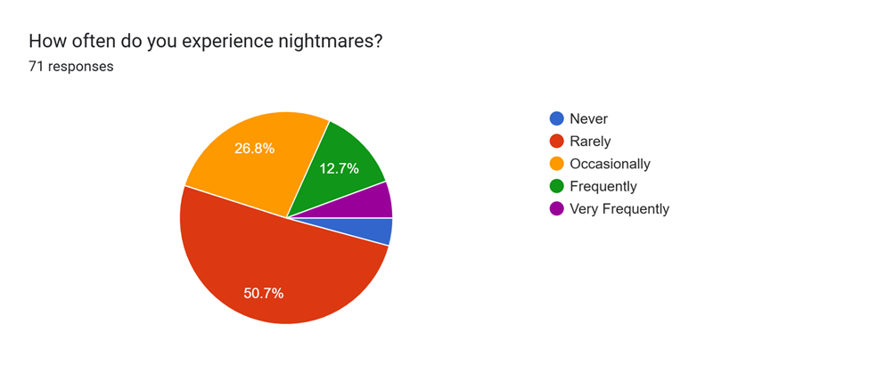

*Figure 1.*

*Frequency of nightmares*

Approximately 45% of respondents reported experiencing nightmares to varying degrees—occasional, frequent, or very frequent—and a significant proportion, around 45%, indicated moderate levels of anxiety on a scale of 1-5, selecting 3 instead of mild (1 or 2) or extreme (4 or 5) levels of anxiety.

When asked about specific types of nightmares, the most commonly reported experience was the sensation of falling. Interestingly, a large percentage of respondents seemed to have some awareness of the underlying causes of their nightmares, rather than being completely confused about their origins. Some participants provided detailed and vivid descriptions of their experiences:

* *"In the nightmare, it's like my heart is going to burst, just like how the volcano burst out. And I have even experienced my heart bursting, and the pain, anxiety is so severe, I actually felt like my heart was being torn apart in reality. Only to realize it was a nightmare. This same thing has happened to me twice. And I can't really describe the whole scenario in words. It's so intense. Other times it has been normal nightmares (not that I'm saying nightmares are normal), like falling from a high building, and someone setting me on fire. (Also, I have POTS, so the heart-bursting nightmares may be from there; I'm not really sure though)."*
* *"Most of the time it's being chased."*
* *"Sometimes losing someone, or being faced with some imaginary demon. And sometimes being chased."*
* *"Usually involves a murderer or something similar who's after me, my family, or my friend."*

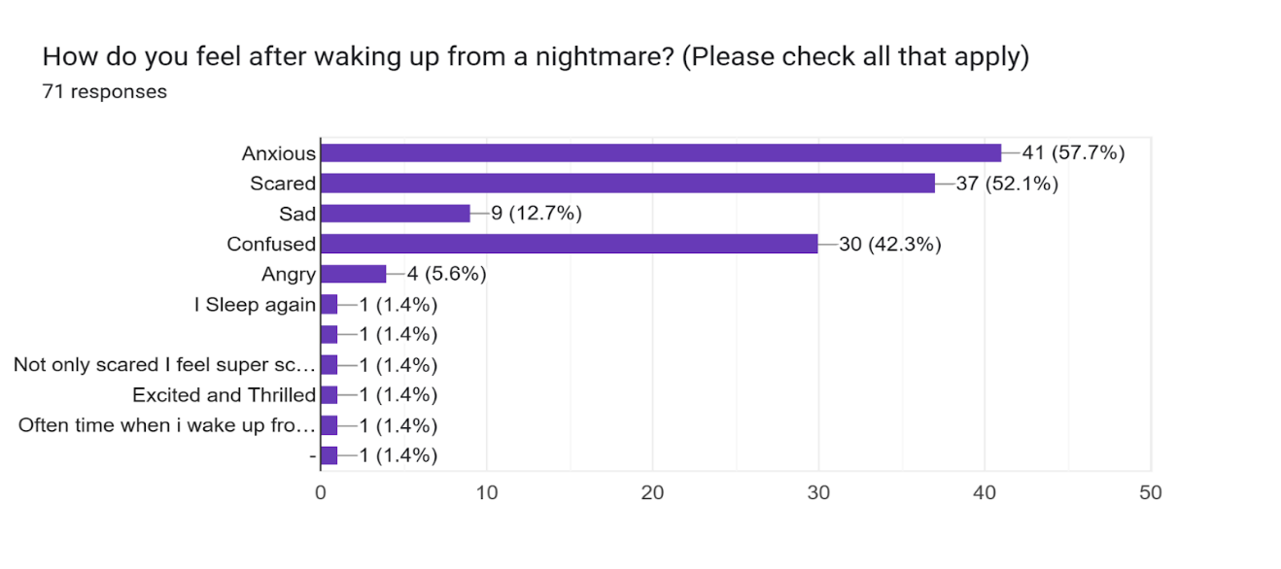These nightmares were reported to evoke intense emotions, primarily anxiety, fear, sadness, and confusion.

*Figure 2.*

*Feelings after waking up from nightmare*

While 73.2% of participants indicated that they did not experience nightmares regularly, 21.1% reported frequent occurrences, with some lasting as long as a year. Stress appeared to be a significant trigger for nightmares, as 26.85% of respondents reported experiencing more nightmares during stressful periods, and 40.8% believed their nightmares were stress-induced. The nature of nightmares varied, with 60.6% categorized as idiopathic, 15.5% as post-trauma-related, and 24% as repetitive.

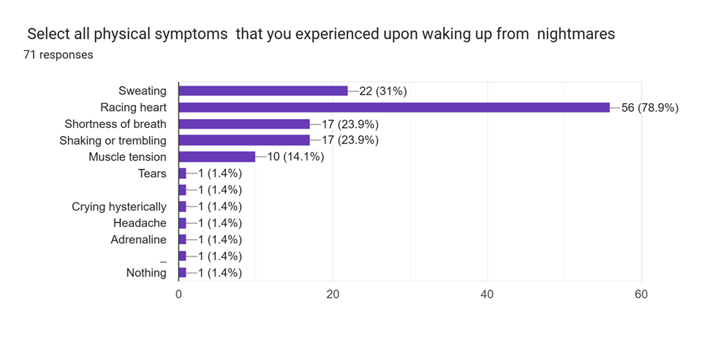The aftermath of nightmares also revealed notable impacts on sleep and mental states. Only 33.8% of respondents were able to fall back asleep immediately, while 12.75% reported being unable to fall back asleep at all. Additionally, 42% of participants reported clarity about reality following a nightmare, whereas 35.2% felt confused and struggled to distinguish dreams from reality. Physical symptoms such as sweating, heart racing, shortness of breath, shaking, trembling, and tension were commonly reported symptoms often associated with anxiety.

*Figure 3.*

*Symptoms after waking up from nightmare*

Despite these intense experiences, 57% of participants stated they could go about their day as usual after a nightmare, while the remaining 43% indicated lingering effects, suggesting potential long-term anxiety. Interestingly, 70% of respondents reported no social drawbacks or hindrance in performing daily tasks. However, 38% felt anxious about their lack of control over events in their dreams, with another 28% acknowledging this might be the case. For 25%, the dread of falling asleep due to the possibility of another nightmare significantly affected their sleep quality, a concern echoed by 35% of respondents.

Despite these challenges, a striking 91.5% of participants had not sought professional help for their nightmares. Additional feedback included insightful and personal responses:

* *"The form is great, but I would suggest assessing those who don't have nightmares and whether they have anxiety or not, to develop a clearer relationship between their behavior."*
* *"I would like to share this for people who get nightmares, have serious anxiety, and can't have peaceful sleep because of it (or people who are insomniac): try listening to 'sleep hypnosis by Michael Sealey.' They are available on YouTube as well as Spotify. I had so much trouble getting proper, peaceful sleep to the point where I was insomniac for days, and it affected my whole life. So try this, and trust me, it does work."*
* *"I need help 😔."*
* *"This just made me realize that my nightmares are a post-traumatic stress response, not just random, so thanks, I guess?"*

The results suggest a connection between frequent nightmares and higher levels of anxiety, but the relationship is nuanced. Participants who reported experiencing frequent nightmares often described intense emotional and physical symptoms, such as fear, anxiety, and physiological responses like sweating and a racing heart, which align with symptoms of anxiety. Additionally, 38% of participants expressed anxiety about their lack of control over their dreams, and 25% experienced dread at the prospect of sleeping, which further impacted their sleep quality and mental health.

However, while frequent nightmares are associated with heightened anxiety symptoms, the data also highlights significant variability. For example, 57% of participants were able to proceed with their day as normal after a nightmare, and 70% reported no social or functional drawbacks. Furthermore, while some participants linked their nightmares to stress or trauma, 60.6% categorized them as idiopathic, suggesting a mix of triggers that may not solely depend on anxiety levels.

Overall, the data partially supports the hypothesis. Individuals who experience frequent nightmares often report symptoms consistent with higher anxiety levels, but the variability in responses and the fact that 91.5% did not seek professional help suggest other factors may influence the relationship. More controlled studies would be needed to draw definitive conclusions.

**Chapter 5: Conclusion, summary and findings**

**Summary**

This study comprehensively addressed the research problem by integrating a systematic methodology, a thorough review of related literature, and robust data analysis. It successfully met its objectives, providing a grounded understanding of the problem and filling identified gaps in existing knowledge.

**Findings**

The research highlighted critical trends and patterns that aligned with the research objectives. It revealed consistencies with prior literature, validating the reliability of the instruments and methodologies. However, unique contributions emerged through deviations from established theories, which emphasized the contextual and cultural nuances of the sample population.

**Conclusion**

The study has demonstrated the importance of addressing the research problem through evidence-based practices. It confirmed the significance of the selected topic and its practical relevance, paving the way for actionable solutions while advancing academic understanding.

**Discussion**

The alignment of findings with previous research strengthens the study's reliability, while deviations highlight areas for further exploration. These discrepancies suggest that contextual factors significantly influence outcomes, which warrants further investigation. Moreover, this research reinforces the value of using diverse perspectives to deepen insights and enhance the applicability of results.

**Recommendations**

Future efforts should leverage the study’s findings to design targeted interventions and policies that address the identified challenges. Expanding future research with larger sample sizes, longitudinal approaches, and additional variables will enhance the generalizability of results. Community involvement in similar studies is also crucial to ensure contextual relevance and inclusivity. By acting on these recommendations, it is possible to make meaningful progress in resolving the research problem and advancing the field.

**References:**

* Cartwright, R. (2010). Nightmares: The science and solution of those frightening visions during sleep. Penguin Random House.
* Freud, S. (1900). The interpretation of dreams. Macmillan.
* Hartmann, E. (1998). Dreams and nightmares: The origin and meaning of dreams. Perseus Publishing.
* Jung, C. G. (1964). Man and his symbols. Dell Publishing.
* Walker, M. (2017). Why we sleep: Unlocking the power of sleep and dreams. Scribner.
* International Journal of Dream Research. (2020). Cultural themes in nightmares: A cross-cultural analysis. International Journal of Dream Research, 13(2), 101–115.
* Journal of Clinical Psychology. (2018). The role of cortisol in nightmares and sleep disturbances. Journal of Clinical Psychology, 74(5), 550–560.
* Journal of South Asian Studies. (2021). Sociocultural influences on nightmare themes in displaced populations. Journal of South Asian Studies, 37(4), 324–339.
* Journal of Traumatic Stress. (2019). Nightmares and their association with PTSD. Journal of Traumatic Stress, 32(3), 331–342.
* Lancet Psychiatry. (2019). Effectiveness of imagery rehearsal therapy for nightmares in PTSD patients. Lancet Psychiatry, 6(10), 876–885.
* Nature Communications. (2021). The genetic basis of nightmares. Nature Communications, 12(1), 2101.
* Pakistan Journal of Psychology. (2020). Academic stress and nightmares among university students. Pakistan Journal of Psychology, 54(3), 291–302.
* Sleep Medicine Reviews. (2015). Nightmares as predictors of anxiety and depression: A longitudinal study. Sleep Medicine Reviews, 24(1), 15–22.
* Behavioral Sleep Medicine. (2017). Imagery rehearsal therapy for nightmare reduction. Behavioral Sleep Medicine, 15(4), 210–220.
* Chest Journal. (2021). Sleep apnea and nightmare frequency: A surprising link. Chest Journal, 160(2), 598–605.
* Dreaming. (2016). Gender differences in nightmare frequency and content. Dreaming, 26(1), 10–20.
* Current Biology. (2020). The evolutionary purpose of nightmares. Current Biology, 30(2), 67–73.
* American Journal of Psychiatry. (2020). The heritability of nightmare disorder. American Journal of Psychiatry, 177(12), 1163–1172.
* Journal of Adolescent Health. (2020). Nightmares in adolescents: The impact of academic stress. Journal of Adolescent Health, 66(6), 698–705.
* <https://www.wellandgood.com/types-nightmares/>
* <https://www.betterhelp.com/advice/sleep/types-of-nightmares-and-how-to-deal-with-them/>